H.T No
Regulations:
A17

Sreenidhi Institute of Science and Technology
(An Autonomous Institution)
Code No: 6B517 Date: 29-Oct-2020 (AN)

B.Tech III-Year I-Semester External Examination, October - 2020 (Supplementary)
DESIGN OF MACHINE MEMBERS-I (ME)

Time: 2 Hours Max.Marks:75

Note: a) No additional answer sheets will be provided.
b) All sub-parts of a question must be answered at one place only, otherwise it will not be valued.
c) Missing data can be assumed suitably.

ANSWER ANY 5 OUT OF 8 QUESTIONS. EACH QUESTION CARRIES 15 MARKS.

1. | a) | Define factor of safety and what are the factors to be considered for deciding the magnitude of factor of safety. | [8M]
 | b) | A cylindrical shaft made of steel of yield strength 700 MPa is subjected to static loads consisting of bending moment 10KN-m and a torsional moment of 30KN-m. Determine the diameter of shaft. Assume factor of safety equal to 2, E = 210 GPa and poisons ratio equal to 0.25. | [7M]
2. | a) | Draw the modified Goodman diagram and explain it. | [5M]
 | b) | A bar of steel has an ultimate tensile strength of 700 MPa, a yield point stress of 400 MPa and fully corrected endurance limit of 220 MPa. The bar is subjected to a mean bending stress of 60 MPa and stress amplitude of 80 MPa. Superimposed on it is a mean torsional stress and torsional stress amplitude of 70 and 35 MPa respectively. Find the factor of safety? | [10M]
3. |  | It is required to design a knuckle joint to connect two circular rods subjected to an axial tensile force of 50 KN. The rods are co-axial and a small amount of angular misalignment between their axes is permissible. Design the joint and specify the dimensions of its components. Consider material as steel 45C8 for all the components whose yield strength is 380 N/mm² and factor of safety 5. | [15M]
4. |  | A bracket is bolted to a coloumn by 6 bolts of equal size as shown in the figure. It carries a load of 50 KN at a distance of 150 mm from the center of coloumn. If the maximum stress in the bolts is to be limited to 150 MPa, determine the diameter of bolt.  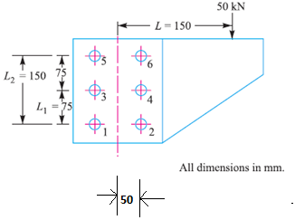 | [15M]
5. | a) | Design a helical compression spring for a maximum load of 1000 N for a deflection of 25 mm using the value of spring index as 5. The maximum permissible shear stress for spring wire is 420 MPa and modulus of rigidity is 84 KN/mm² | [15M]
6. |  | A bracket as shown in the figure, carries a load of 40 KN. Calculate the size of weld if the allowable shear stress is not to exceed 80 MPa  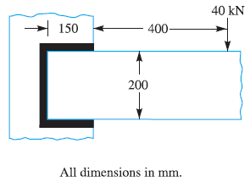 | [15M]
7. | a) | What is the difference between caulking and fullering? Explain with the help of neat sketches. | [8M]
 | b) | Explain about bolt of uniform strength. | [7M]
8. | a) | Explain the following terms of the spring  i) Free length ii) Solid length iii) Spring rate iv) Active and inactive coils v) spring index | [10M]
 | b) | List the various types of keys and draw their sketches neatly. | [5M]

-- 00 -- 00 –

